

Azure Machine Learning AutoML Demo

Please go to

<https://github.com/DataSnowman/carprice/tree/master/dataset>

git repository for latest version

***Enable automated building of machine learning with the goal of accelerating, democratizing and scaling AI***

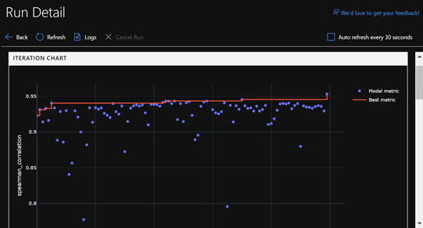

**Darwin Schweitzer** [**darsch@microsoft.com**](mailto:darsch@microsoft.com)

Senior Business Strategy Manager, Intelligent Cloud – Data & AI

**Sanjay Chopra Sanjay.Chopra@microsoft.com**

Senior Business Strategy Manager – AI, Intelligent Cloud Data AI SS

AGENDA

Contents

About this demo 3

Pre-requisites 5

AutoML DEMO Setup (Create and run an AutoML experiment prior to giving the demo) 7

Create an AutoML Experiment 7

Demo: INTRODUCING Azure Machine Learning AutoML 13

Overview 13

Review the AutoML Experiment 14

Power BI Dataflow DEMO Setup (If not using the slides, create the Power BI Dataflow prior to giving the demo) 19

Setup Power BI Dataflow 19

## About this demo

**If you would like to see how this AutoML demo can be delivered check out this** [**Video**](https://msit.microsoftstream.com/video/01e6dd72-0efe-4f02-a7b0-2d2ea3080820) **from the Ready 2019 Data & AI Pre-Day**

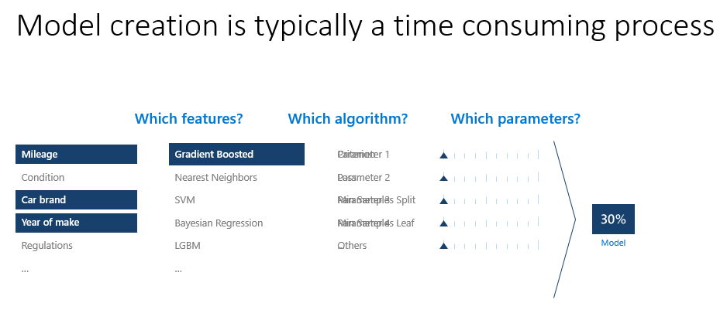

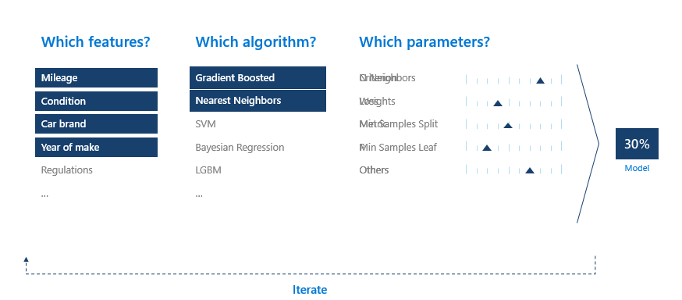

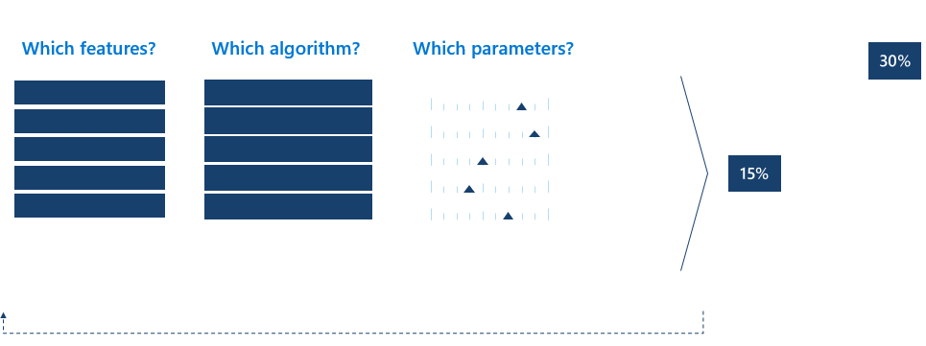

## Pre-requisites

| **Prerequisite** | **Screenshot** |
| --- | --- |
| 1. **Prerequisite**: You will need an Azure Subscription for this demo. If you do not have an Azure account, you can sign up for free at [https://azure.microsoft.com/free/](https://azure.dmicrosoft.com/free/) |  |
| 1. **Prerequisite**: You will need to create a Machine Learning service workspace in an Azure Resource Group. You can find details on creating an AML service workspace [here](https://docs.microsoft.com/en-us/azure/machine-learning/service/how-to-manage-workspace#create-a-workspace) |  |
| 1. **Prerequisite**: Save the csv file **carprice.csv** that is available [here](https://automlsamplenotebookdata.blob.core.windows.net/automl-sample-notebook-data/carprice.csv) to a folder on your machine, e.g. to Documents\AutoML\CarPrice |  |

## AutoML DEMO Setup (Create and run an AutoML experiment prior to giving the demo)

| Create an AutoML Experiment | | |
| --- | --- | --- |
| **Narrative** | **Steps** | **Screenshot** |
|  | 1. Open the Azure Machine Learning workspace by clicking on it in the Azure portal |  |
|  | 1. Click on **Automated machine learning** under the Authoring section |  |
|  | 1. Clickon **Create experiment**. |  |
|  | 1. Enter an **Experiment name** and click on **Create a new compute** |  |
|  | 1. Enter a **Compute name**, and **Select virtual machine size**, set Minimum number of nodes to **0**, set Maximum number of nodes to **6,** and click **Create**   This may take a couple minutes |  |
|  | 1. **Select a training compute** and chose the new compute created above. Click **Next** |  |
|  | 1. Click on Upload to upload the carprice.csv you downloaded in the prerequisites. |  |
|  | 1. Select carprice.csv |  |
|  | 1. Preview the data |  |
|  | 1. Ignore the SYMBOLING and NORMALIZED-LOSSES columns (features) by clicking on the Included/Ignored slider |  |
|  | 1. Chose **Regression** for the prediction task and **price** for Target column. 2. Click **Start** |  |
|  | 1. Let it run to finish to complete the experiment. Do this the first time ahead of the demo to have a completed experiment. |  |

## Demo: INTRODUCING Azure Machine Learning AutoML

| Overview | | |
| --- | --- | --- |
| **Narrative** | **Steps** | **Screenshot** |
| Humongous Insurance wants to provide its claims department with a good way of estimating the value of their members automobiles when they have their car written off in a accident or when a member is adding a new car. This demo shows how easy it is to take a historical dataset an use it to predict the price/value of a car.  Show slides explaining AutoML (see slides 2-6 in AutoMLslides.pptx) |  |  |

| Review the AutoML Experiment | | |
| --- | --- | --- |
| **Narrative** | **Steps** | **Screenshot** |
|  | 1. Click on the Run ID of the completed experiment |  |
|  | 1. View the Iteration Chart and view some of the point on the graph |  |
|  | 1. Scroll down to the Iterations and talk about the models and their Spearman Correlation |  |
|  | 1. Click on VotingEnsemble and look at the graph Predicted vs. True |  |
|  | 1. Scroll down and click on **Deploy Model VotingEnsemble** |  |

|  |  |  |
| --- | --- | --- |
|  | Note that if you click the Deploy button it is going to take 20 minutes to deploy the model. You will also have to delete the deployment, so you are not charged on Azure to continue to run the compute in an Azure Container Instance (ACI)  6. To show the customer how you would deploy a model, enter a Deployment name and click the **Deploy** button.  In the next step you can use a model that has already been deployed for you. You will need to join a security group and build a Dataflow in Power BI in advance to show it to customers. |  |
|  | 7. If you do click Deploy above, click on Images in the Assets section of the AML service workspace to see the image. The status will be Running until the image is created and then it will change to Succeeded |  |
|  | 8. If you do click Deploy above, click on Deployments in the Assets section of the AML service workspace to see the deployment. |  |
|  | 9. If you did click deploy you can always delete the ACI deployment by clicking the box in front of the deployment and click on Delete. |  |
|  | 10. Consume the AKS web service in Power BI  Either just show slide 7 in AutoMLslides.pptxb [**deck**](https://microsoft.sharepoint.com/:p:/t/AIDemos/ERCCT50i425BnNqZkWJtvWcB-KV6IztNl7qO6Yjrp8uY4Q?e=wCkZi5) |  |
|  | Hope you enjoyed the demo | If you would like to setup you own Power BI Dataflow see the next section. |

## Power BI Dataflow DEMO Setup (If not using the slides, create the Power BI Dataflow prior to giving the demo)

| Setup Power BI Dataflow | | |
| --- | --- | --- |
| **Narrative** | **Steps** | **Screenshot** |
|  | 1. Click [**HERE**](https://idwebelements/GroupManagement.aspx?Group=access-ai-models&Operation=join) to join the **access-ai-models** security group via idweb |  |
| To add the real Power BI experience to this demo versus using the screen recording setup a dataflow on your own. You can then demo this. Note: The AI insights part of this requires that the carpricedemo webservice is running on ACI or AKS.  This webservice should be setup for you if you joined the **access-ai-models** security group | 1. Go to [https://powerbi.com](https://powerbi.com/) and Sign in 2. Create a workspace |  |
|  | 1. Give the Workspace a name like CarpriceDemo. Note that the Workspace name must be globally unique so add you initials or pick something unique that works for you. |  |
|  | Create new content   1. Click on Get started under Dataflows |  |
|  | 1. Click on Add new entities |  |
|  | 1. Select Text/CSV as a Data source |  |
|  | 1. Paste the URL <https://automlsamplenotebookdata.blob.core.windows.net/automl-sample-notebook-data/carprice.csv>forthe csv file **carprice.csv** 2. Click Next |  |
|  | 1. Enter a Name for the query (like carprice) 2. Click Save & close |  |
|  | 1. Name the dataflow (like carpriceDF) 2. Click Save |  |
|  | 1. Click on Refresh now |  |
|  | 1. Click on the left most **Edit entity** icon in Actions |  |
|  | 1. Find the bore column. 2. Click on the dropdown 3. Click on Text filters |  |
|  | 1. Choose **does not equal** 2. Enter **?** 3. Click OK |  |
|  | 1. Find the **bore** column again |  |
|  | 1. Click on the datatype ABC and select **1.2 Decimal number** |  |
|  | 1. Find the **stroke** column 2. Click on the datatype ABC and select **1.2 Decimal number** |  |
|  | 1. Find the **horsepower** column 2. Click on the datatype ABC and select **123 Whole number** |  |
|  | 1. Find the **peak-rpm** column 2. Click on the datatype ABC and select **123 Whole number** |  |
|  | 1. Click Save & close |  |
|  | 1. Click on Refresh now |  |
|  | 1. Click on the left most Edit entity icon in Actions |  |
|  | 1. Click on AI insights |  |
|  | 1. Select the AzureML.carpricedemo model and click Apply |  |
|  | 1. If you get this message click Continue |  |
|  | 1. Review the carprice prediction in the Power BI Dataflow |  |
|  | 1. Click on Cancel so the next you use the Dataflow it is starting at the same point. If you forgot you can just delete the last 3 steps up to and including “Invoked AzureML.carpricedemo” |  |

## Demo Power BI Dataflow (If not using the slides, and you created the Power BI Dataflow above here is the demo)

| Setup Power BI Dataflow | | |
| --- | --- | --- |
| **Narrative** | **Steps** | **Screenshot** |
|  | 1. Click on the left most Edit entity icon in Actions |  |
|  | 1. Click on AI insights |  |
|  | 1. Select the AzureML.carpricedemo model and click Apply |  |
|  | 1. If you get this message click Continue |  |
|  | 1. Review the carprice prediction in the Power BI Dataflow |  |
|  | 1. Click on Cancel so the next you use the Dataflow it is starting at the same point. If you forgot you can just delete the last 3 steps up to and including “Invoked AzureML.carpricedemo” |  |